TCS3351 CRYPTOGRAPHY AND DATA SECURITY
Tutorial 8 - Modern Asymmetric Key Ciphers: Principles

- State the major differences between symmetric-key and asymmetric-key cryptosystems.

Answer:
Symmetric-key cryptosystem: Uses only one private key in both encryption and decryption processes. It does not ensure integrity and non-repudiation properties. That is, it does not protect the sender from the receiver forging the message (or signature) or claiming the message (or signature) sent by the sender.

Asymmetric-key cryptosystem: Uses a pair of public and private keys, with the public key used in encryption and verification. The private key used in decryption and signing processes. It ensures integrity and non-repudiation in communication.

- With the help of a diagram, explain how the public-key cryptosystem can be used to provide authentication/digital signature.

Answer:
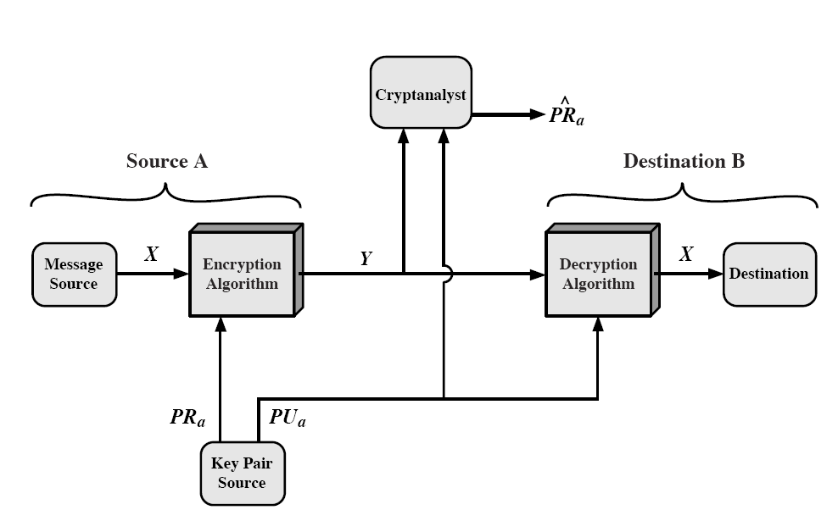

In a public-key cryptosystem, a message signer $A$will sign the message using his private key $σ=Sig\left({Prv}_{A},M\right)=Enc\left(Prv_{A},M\right)$, which the signer himself can only prepare. When the signature is sent to the receiver, he can verify the authenticity and validity of the signature using the signer’s public key $M=Vfy\left({Pub}_{A},σ\right)=Dec\left({Pub}_{A},σ\right)$, which can be done by anyone who receives the signature.

- With the help of a diagram, explain how the public-key cryptosystem can be used to provide both confidentiality and authentication.

Answer:

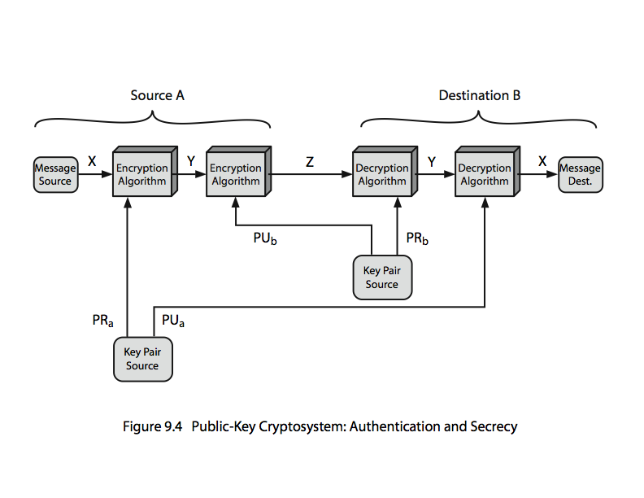

Both confidentiality and authentication can be achieved using a hybrid public-key cryptosystem, in which two pairs of public-private keys are used. A pair of public-private keys from the sender $A$, $\left(Prv_{A},Pub_{A}\right)$ will be used in signing-verifying the message, while a pair of public-private keys from the receiver $B$, $\left(Prv_{B},Pub_{B}\right)$will be used in encrypting-decrypting the message.

The message is firstly signed using $Prv_{A}$ and next encrypted using $Pub_{B}$. When the message is received, it will be decrypted using $Prv_{B}$ and finally verify using $Pub_{A}$.
Real case: B4 signing, you need to hash the msg then padded it.

>>>
  - Alice 1 2 send a signed small document to Bob and only Bob can see the document.
- Sign 1st. Encrypt Later.
- Alice key is 2048 bits
  - Sign(doc, AlicePriv) = signature. 256 bytes
  - Encrypt(RSA, signature, BobPub) = CipherTxt. 512 bytes ***
  - Send CIpherTxt to Bob.
- Bob key is 4096 bits.
  - Decrypt(RSA, Ciphertxt, BobPriv) = Signature
  - Verify(Signature, AlicePub) = True/False. If True, he will get the doc.

- Briefly explain the One-way and Trap-door one-way functions.

Answer:
One-way function: A function maps every object in a domain into its corresponding unique image in the range, such that the function is easily computable but infeasible (or difficult) to invert it. Known x, find y = f(x) is easy. Known y, find (x) is extremely hard.

Trap-door one-way function: A function maps every object in a domain into its corresponding unique image in the range, such that the function is easily computable but infeasible (or difficult) to invert it, except when trap-door information is given.

References:

1. Forouzan, B. A. & Mukhopadhyay, D. (2015). Cryptography & Network Security (3rd ed.). McGraw-Hill.

2. William Stallings, “Cryptography and Network Security – Principles and Practice”, Seventh Edition, Prentice Hall, 2017

